The Lion Sleeps Tonight – Beach Boys
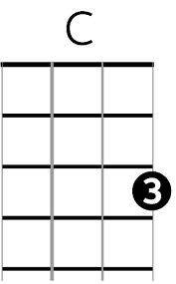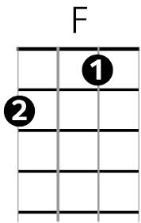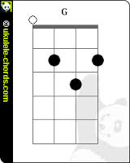
Strum Pattern: D D U D D U
1 + 2 + 3 + 4 +
| C |  In the Jungle,  | F |  the mighty jungle,  | C | G |  the lion sleeps tonight.  | C |  In the jungle,  | F |  the quiet jungle,  | C | G |  the lion sleeps tonight.  | C |  Ah weeeeee  | F | C | G |  Eeee ee E um um away (REPEAT) | | C |  Near the village,  | F |  the peaceful village,  | C | G |  the lion sleeps tonight.  | C |  Near the village,  | F |  the peaceful village,  | C | G |  the lion sleeps tonight.  | C |  Ah weeeeee  | F | C | G |  Eeee ee E um um away (REPEAT)

